**BDA EXPERIMENT 07**

| **Name:** | **Class/Batch:** |
| --- | --- |
| **Roll No:** | **PRN:** |

**Flajolet Martin algorithm**

**Program:**

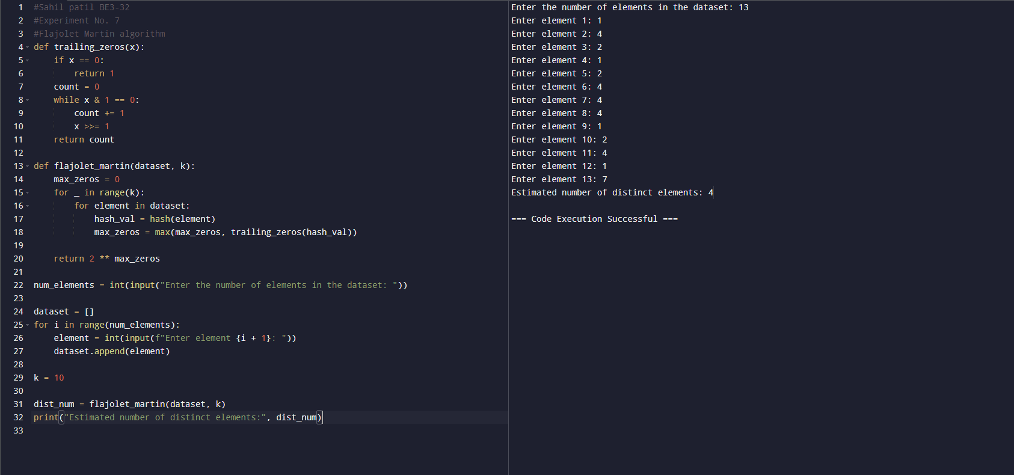

**Output:**

